13: Slicing and Analyzing Arrays
In this challenge, your objective is to demonstrate your proficiency in creating arrays from lists and extracting specific information from those arrays. You have the following data:
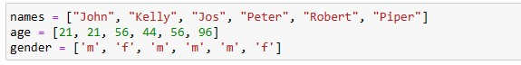
- Using the data above, create an array and transpose it. The creation of an array and transposition should be combined into one code. The code should return a transposed array.
- Using slicing or indexing, write code to return the last row of the transposed array (question 1).
- Using slicing or indexing, write code to return the first two rows of the transposed array (question 1).
- Using slicing, write a code that returns the age of Peter. Return Peter’s age as an integer data type.
- Write code to return an array of Kelly's age and gender using slicing (from the transposed array in question 1).
- One of the uses of slicing is for data visualization. Slicing is often used in data visualization to extract specific portions of a dataset for plotting. Write code to create a subarray of the ages (only ages) in the transposed array using slicing. Using Matplotlib, plot a histogram of the age array. Your graph should have an xlabel, an ylabel, and a title.

